IFPDA FOUNDATION ANNOUNCES
ANNUAL GRANTS AND AWARDS FOR 2020
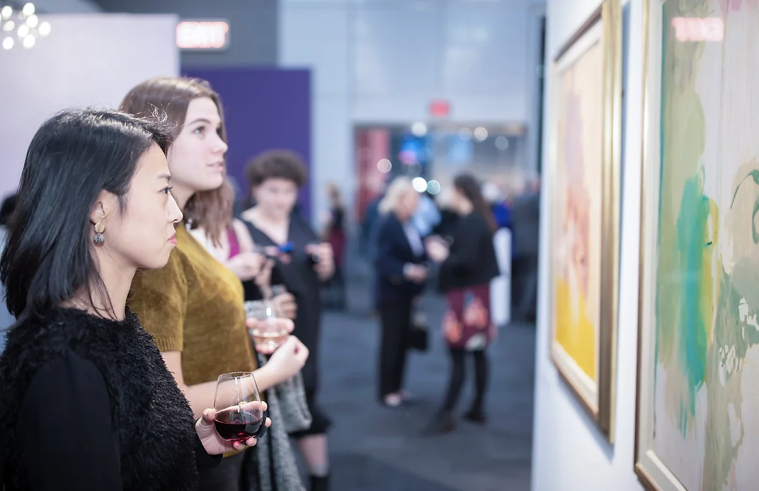

September 10, 2020, New York, NY: Jenny Gibbs, Executive Director of the International Fine Print Dealers Association (IFPDA) is pleased to announce the recipients of the 2020 IFPDA Foundation Grants and the 2020 IFPDA Foundation Book Award.

Each year, the IFPDA Foundation awards a select number of grants to museums and non-profit organizations from around the world for exhibitions, publications, and educational projects promoting a greater awareness and understanding of printmaking as an artistic medium. This year’s recipients include seven esteemed organizations and museums that expand the horizons of this medium and expose printmaking to new audiences.

“The IFPDA Foundation Grants and Book Awards are unique in that they highlight the vitality of the printmaking world and champion its accomplishments and continued growth,” said Jenny Gibbs, Executive Director of the IFPDA. “We are thrilled to honor and take part in so many outstanding commitments to the art of printmaking through the donation of IFPDA Foundation funds. Through our funding of these important programs, we hope to provide valuable support for all the communities that make up the art world ecosystem.”

2020 IFPDA Foundation Grant Recipients
Blanton Museum of Art | Austin, TX | After Michelangelo, Past Picasso: Leo Steinberg's Library of Prints
El Museo del Barrio | New York, NY | Taller Boricua: A Political Print Shop in New York
Free Library of Philadelphia Foundation | Philadelphia, PA | For the Greatest Number: Artifacts of the New Deal
Guttenberg Arts | Guttenberg, NJ | Guttenberg Arts Space & Time Artist Residency Summer and Fall 2020 Programs
The Hermitage Museum & Gardens | Norfolk, VA | Whistler and Company: The Etching Revival: The Hermitage Museum and Gardens 2021
Hunterdon Art Museum | Clinton, NJ | PRINT+: Sameness and Otherness in Contemporary Print Media
International Print Center New York | New York, NY | Living In America
Katonah Museum Of Art Inc | Katonah, NY | Understanding Prints in the Katonah Museum of Art Exhibition ARRIVALS
New York Public Library | New York, NY | "Fortune and Folly in 1720" exhibition, and the publication: Meltdown! Picturing the World's First Bubble Economy
Seattle Print Arts | Seattle, WA | Seattle Print Arts Community Education
Self Help Graphics & Art | Los Angeles, CA | SHG Biennial Printmaking Summit
The Todd Art Gallery at Middle Tennessee State University | Murfreesboro, TN | Screenprint Biennial Symposium
Van Gogh Museum | Amsterdam,  The Netherlands | Educational video on the technique of color lithography in exhibition from Proof to perfection

The IFPDA Book Award Grantees for 2020
The annual IFPDA Book Award was founded in 2004 to honor books, articles, and catalogues on fine art prints which demonstrate excellence in research, scholarship, and the discussion of new ideas in the fields of printmaking, history and connoisseurship. The two grantees this year are:

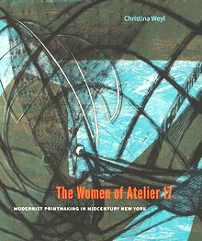
The Women of Atelier 17
Modernist Printmaking in Mid Century New York
Christina Weyl
Yale University Press
In this important and timely book, Christina Weyl takes us into the experimental New York print studio Atelier 17 and highlights the women whose work there advanced both modernism and feminism in the 1940s and 1950s, defying gender norms through novel aesthetic forms and techniques. Weyl focuses on eight artists—Louise Bourgeois, Minna Citron, Worden Day, Dorothy Dehner, Sue Fuller, Alice Trumbull Mason, Louise Nevelson, and Anne Ryan—who bent the technical rules of printmaking and blazed new aesthetic terrain with their etchings, engravings, and woodcuts.

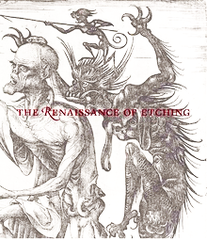
The Renaissance of Etching
Catherine Jenkins, Nadine M. Orenstein, and Freyda Spira
Published by The Metropolitan Museum of Art/Distributed by Yale University Press
An accompaniment to the highly acclaimed Met exhibition which took place from October 23, 2019–January 19, 2020, the book is the first comprehensive look at the origins and diffusion across Europe of the etched print during the late 15th and early 16th centuries.

The etching of images on metal, originally used as a method for decorating armor, was first employed as a printmaking technique at the end of the 15th century. This in-depth study explores the origins of the etched print, its evolution from decorative technique to fine art, and its spread across Europe in the early Renaissance, leading to the professionalization of the field in the Netherlands in the 1550s. Beautifully illustrated, this book features the work of familiar Renaissance artists, including Albrecht Dürer, Jan Gossart, Pieter Breughel the Elder, and Parmigianino, as well as lesser known practitioners, such as Daniel Hopfer and Lucas van Leyden, whose pioneering work paved the way for later printmakers like Rembrandt and Goya.

About the IFPDA and the IFPDA Foundation
The International Fine Print Dealers Association (IFPDA) represents more than 150 vetted international art galleries and publishers who champion the work of artists in printmaking from old master to contemporary. Each year the IFPDA organizes the Fine Art Print Fair in New York, the largest and longest-running art fair in New York showcasing 500 years of artists working in print. This year’s Fair will take place online October 7 - November 1, 2020. Proceeds from the IFPDA Fine Art Print Fair benefit the IFPDA Foundation, which awards curatorial, exhibition and artists grants in the field of printmaking and scholarship.

IFPDA Print “Month” | October 7 - November 1, 2020
This year’s IFPDA Print Week will occupy an entire month and will celebrate 500 years of printmaking with the online IFPDA Fine Art Print Fair as the centerpiece alongside cultural partners including The Metropolitan Museum of Art, the Brooklyn Museum, MoMA, the Whitney Museum of American Art, and The New York Satellite Print Fair. This year in lieu of in-person public programs, offerings will include virtual exhibitions and tours, gallery talks, and panel discussions.

IFPDA Fine Art Print Fair
ONLINE EXCLUSIVE
OCTOBER 7 - NOVEMBER 1, 2020
https://www.ifpda.org/
@ifpda

Media Contacts
Sharp Think, New York
Magda Grigorian, magda.grigorian@sharpthink.com
Lauren Cody, lauren.cody@sharpthink.com

